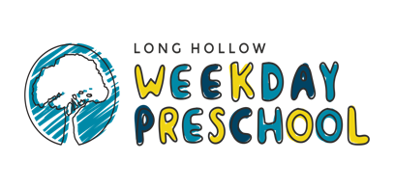

2026-2027 Calendar

August 7 Open House
11 First Day of School

October 1 Community Helper Day
6-8 Closed for Fall Break
29 Pumpkin Patch Day

November 3 Closed for Election Day
24-26 Closed for Thanksgiving Break

December 15 Christmas Program (3, 4, and 5 yr. classes)
17 Class Christmas Parties
22-1/5 Closed for Christmas Break

January 7 Return from Christmas Break

February 11 Class Valentine Parties

March 18 Class Easter Egg Hunts
23-25 Closed for Spring Break

April 8 Pastries for Parents
23 Sumner County Kindergarten Registration
29 Field Day

May 4-6 Teacher Appreciation Week
18 PreK Graduation
20 Last Day of School

